

**Benha University**

**Faculty of Engineering - Shoubra**

**Academic year 2019-2020**

**______________________________________________________________________**

**Name:** Ahmed Mohamed Mansour Abd-allah

**B.N:** 133

**Date:** 27/5/2020

**Topic:** Artificial Intelligence.

**Application Brief:**

The goal of choosing this topic is to know what is artificial intelligence?

And that it is one of the branches of computer science, and one of the main pillars on which

The technology industry is based in the current era.

And also know the applications that include artificial intelligence, such as:

### 1- Reasoning

### 2- Knowledge

### 3- Planning

### 4- Communication

### 5- Perception

And what are the advantages and disadvantages of this technique?

Finally, what is the future that waits this breakthrough, which will make a big change in our world.

And since all scientists are working hard in developing this technique, because it will be the basis

In the future as this technology will reduce human mistakes and has many other uses...

# Screen Shot: 1

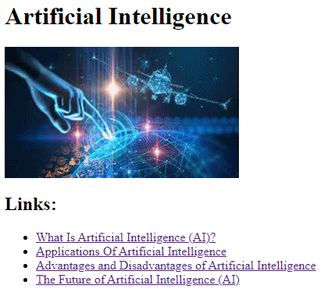

# Source code: 1

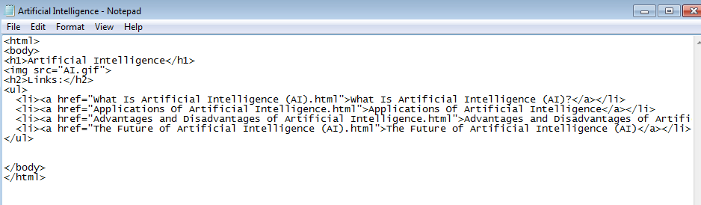

Screen Shot: 2

# 

# Source code: 2

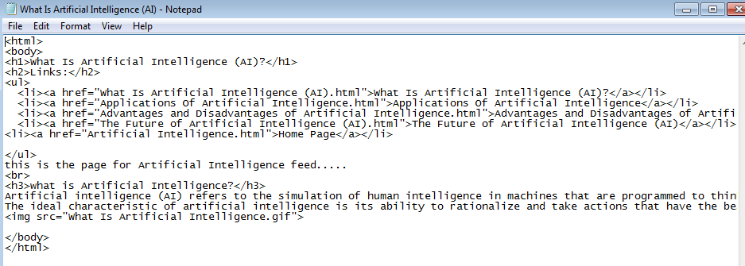

Screen Shot: 3

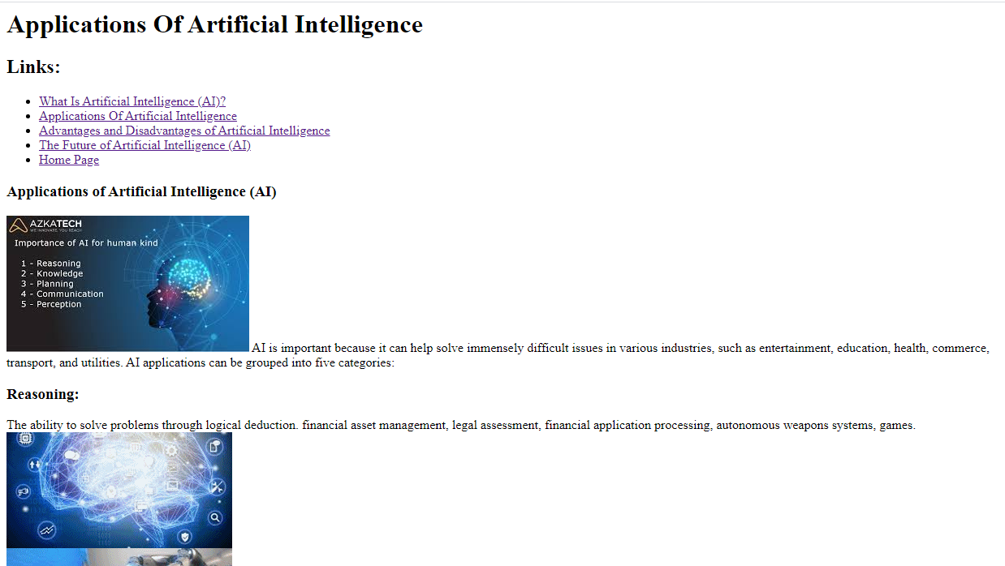

# Source code: 3

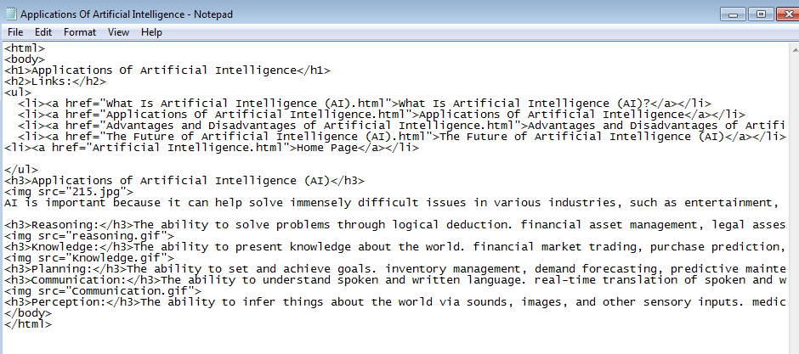

# Screen Shot: 4

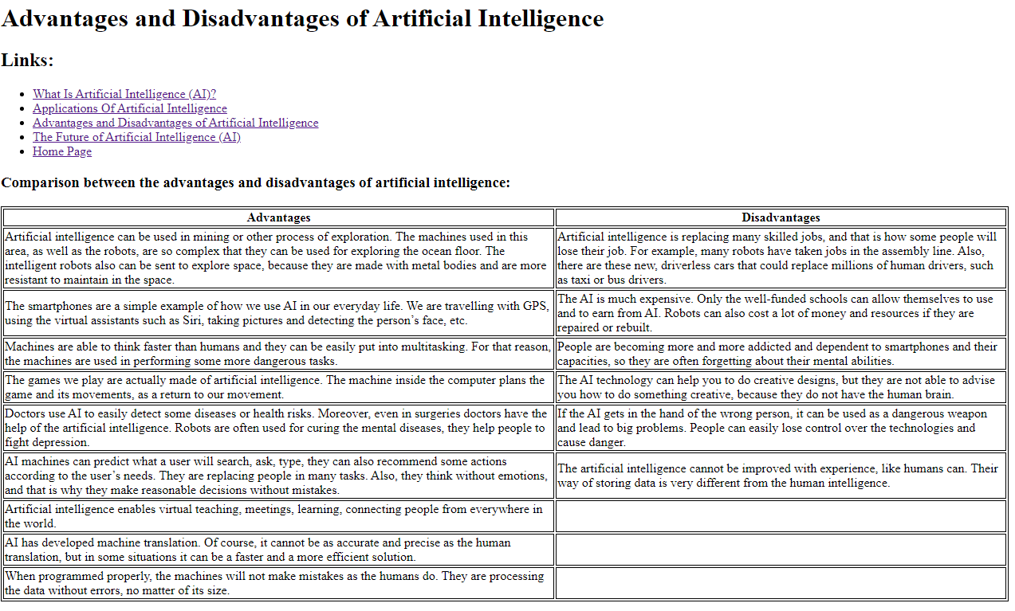

# Source code: 4

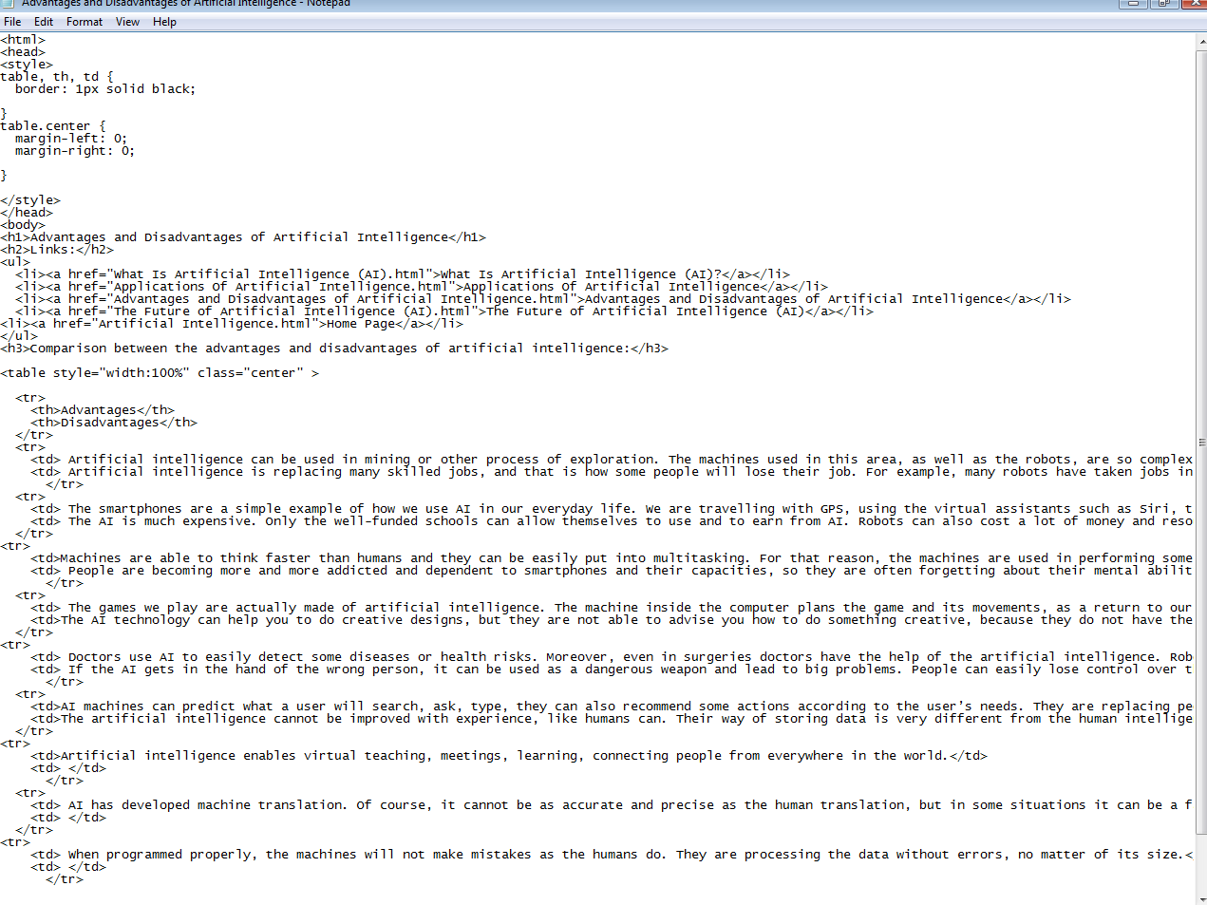

# Screen Shot: 5

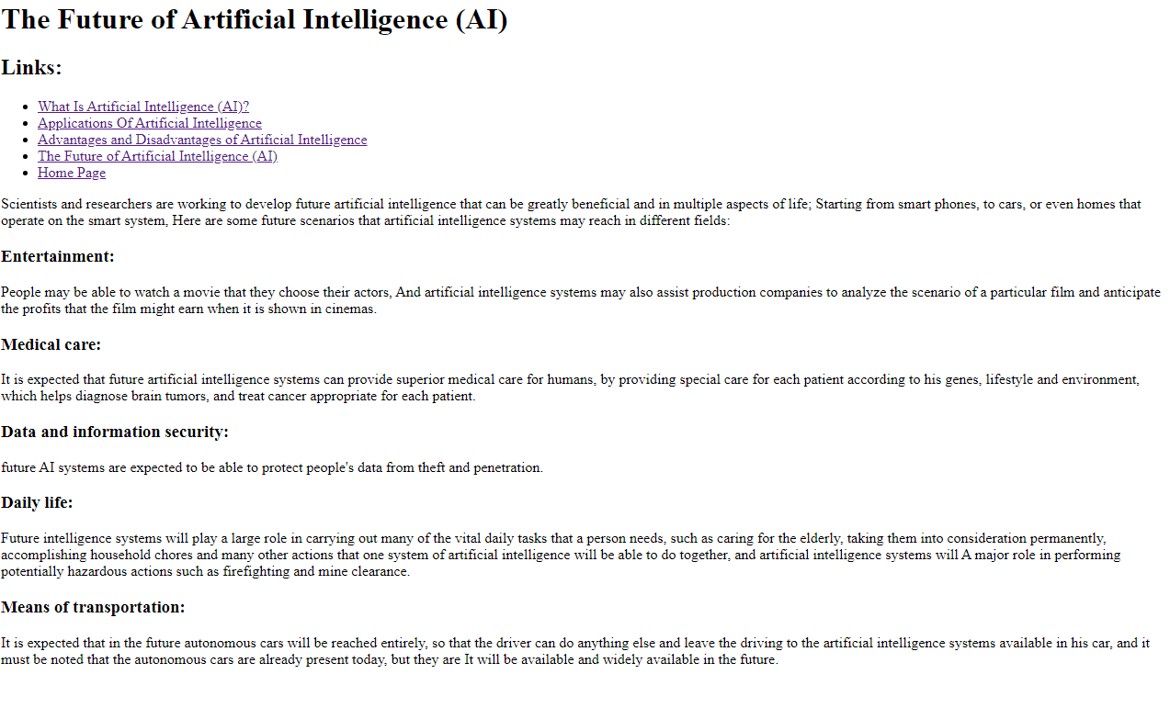

# Source code: 5

